1.Create a Kanban Board to Visualize the Tasks.
- Create Columns for To Do, In-Progress and Done.
- Add at least 5 Sample Tasks
Move the Tasks across the Columns to Simulate the Workflow
By using jira:
Step:-1
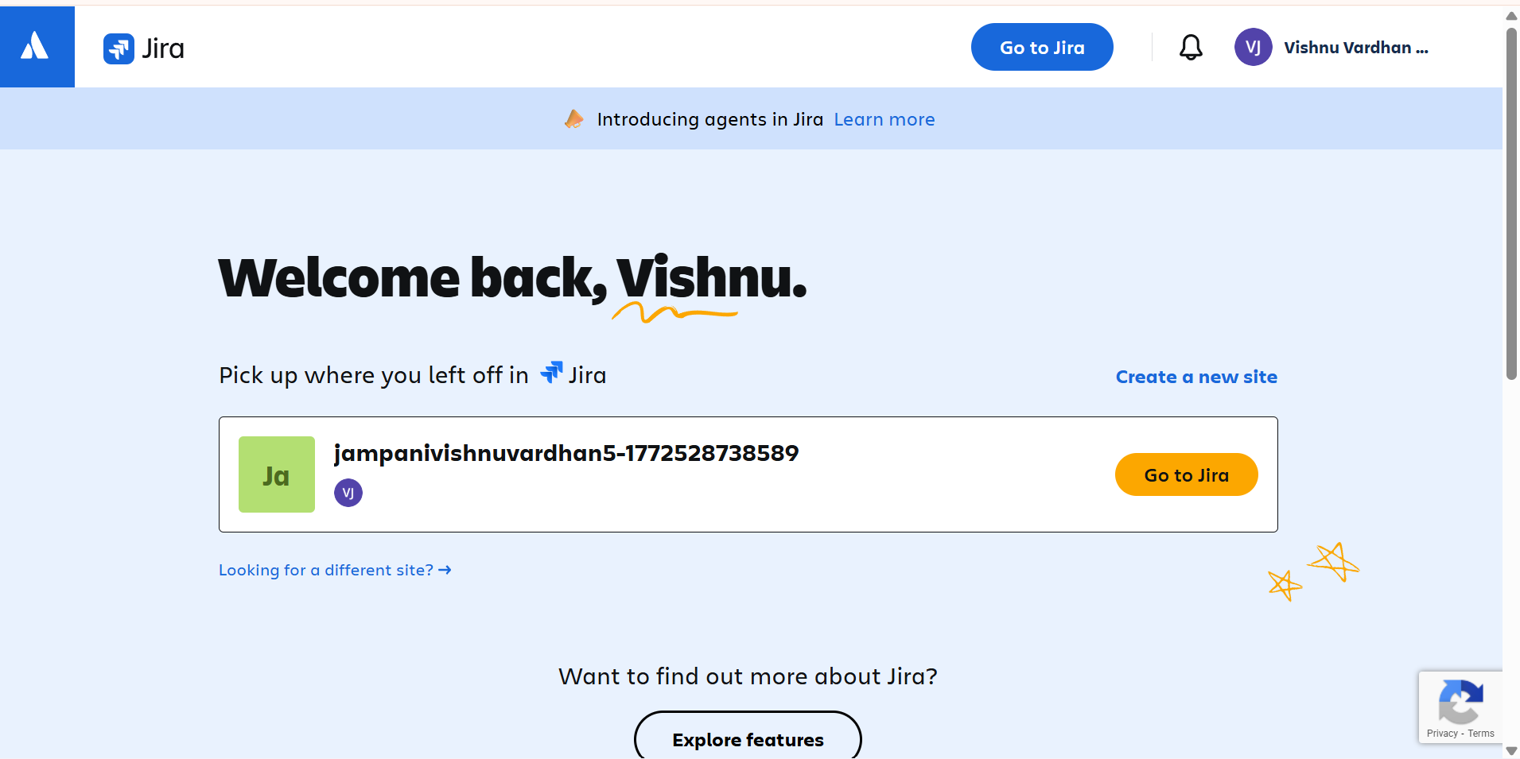
Step:-2
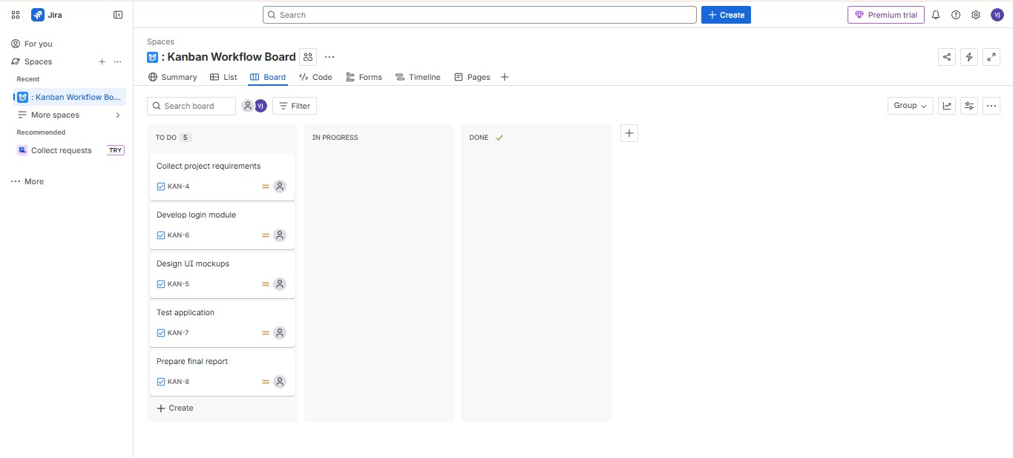
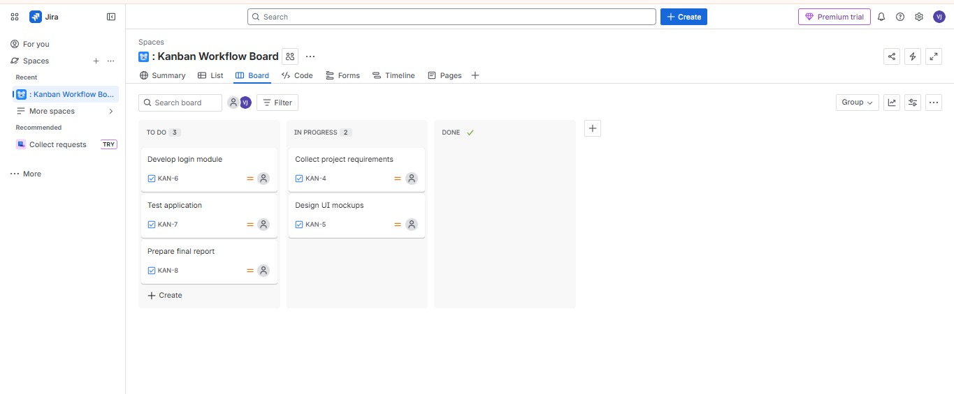
Step:-3

Step:-4
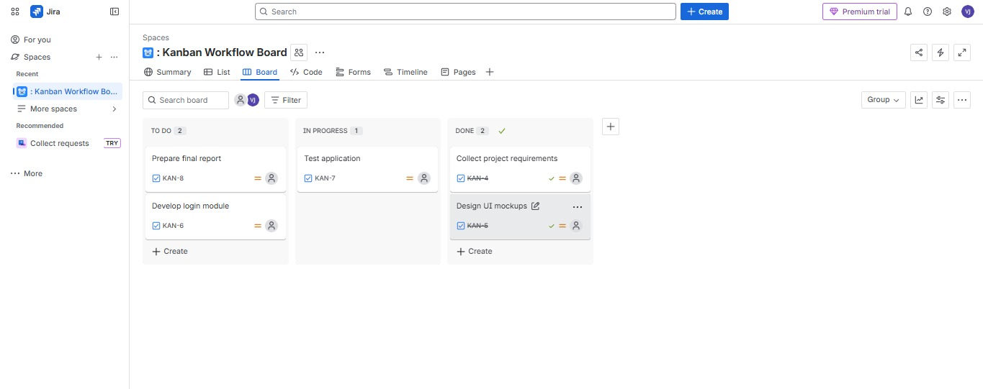
Using by Trello:
Step:-1
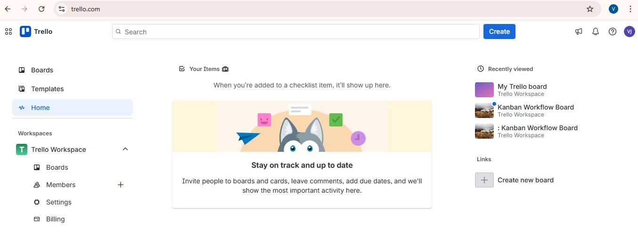
Step:-2
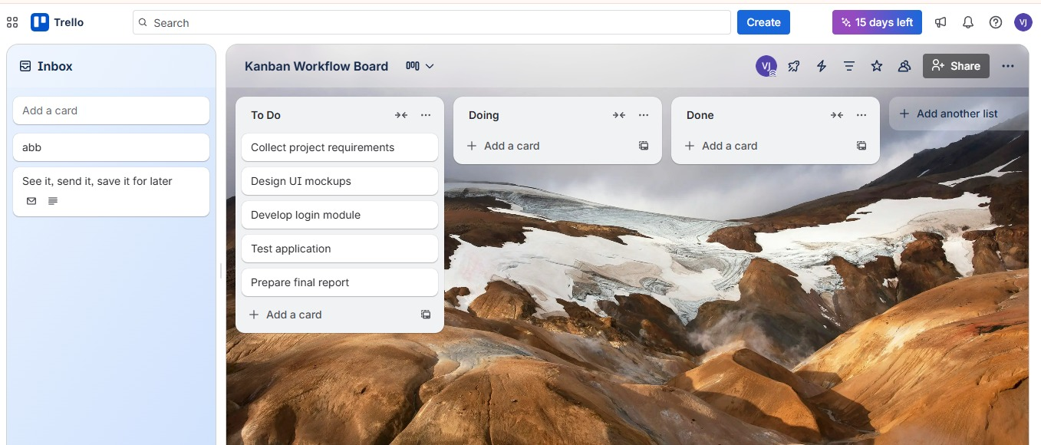
Step:-3
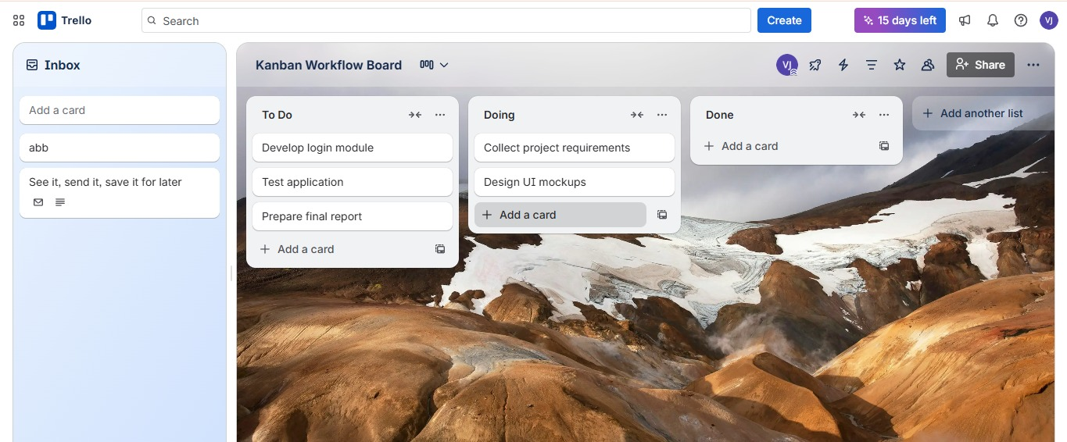
Step:-4
